What is the purpose of a Firewall?
Firewalls are absolutely vital for keeping network security in force. The firewall stops and controls the traffic that comes between your network and the different sites you go to. A firewall is a constituent of a company’s network protection, and it acts to keep in force the network security policy. It can log inter-network activity with efficiency. It can also reduce a network’s vulnerability. Whenever an organization is connected to the Internet but is not using a firewall, any host on the network has direct access to all resources on the internet. If you don’t have a firewall, every host online can attack every host in your network.
Firewall protection
Before you understand the many Firewall Protections, you should know firewall’s limitations first.
Here they are:
- not guarantee data integrity
- not support authenticity of the source of data
- no control over how the packets were created
- not support confidentiality- no encryption among different firewalls unless it is incorporated with VPN features
- don’t protect against some Internet threats like virus attack and/or password cracking
- Do not provide protection from insider threats i.e. Insider Attacks
- can’t protect against traffic that doesn’t go through it (example: dial-up modems in the private network can be a backdoor)
- Once pass through it, it can do nothing!
- Single point of failure
Definitely there are more, can you think of some more?

Firewall cannot deal with internal network attack
Firewall is a perimeter security device. A perimeter security device is only good at protecting the internal network from external attack. That means if an intrusion originates from internal network, then firewall cannot deal with it.
Statistics shows that most of the network attacks of an organization comes from internal employee and hence most likely comes from internal network. Firewall cannot handle this kind of network attacks.
To compliment Firewall’s limitation in dealing internal network attacks, we need other devices like Intrusion Detection System (IDS), and of course other common security measures in areas like physical security.

What is Screened Subnet Architecture?
Let’s take a look at how a typical Screened Subnet Architecture is setup:
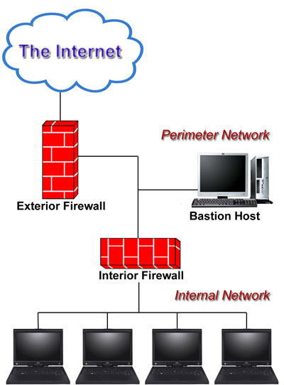

Screened Subnet Architecture refers to setup a firewall (or two firewalls) in a way that there is a separate subnet dedicated for network di-militarized zone (DMZ). The traffic comes from external Internet can only get to the DMZ whereas internal users can access the DMZ only before their traffic going to reach Internet.
Bastion Hosts are hosted in the DMZ. Those hosts are designed to serve external visitors who would like to request services from the network owners. HTTP, FTP and SMTP services are common services provided by Bastion Hosts in DMZ. Since Bastion hosts are aimed at supporting external users’ access, they have to be built against possible Internet attacks.
DMZ is setup in the security concept of layered defending. External hackers, even though they can potentially hack those Bastion hosts in success, they still need to figure out the way to get into the internal networks. This extra layer adds difficulty because all external servers are in DMZ. Hackers are unlikely have any direct access to any hosts in the internal network.
To setup DMZ, the most direct way is to use two firewalls with two network interfaces each. One Firewall is connected to internal network and the other one connected to external Internet. These two firewalls are then joined together using their remaining interface to form a subnet called DMZ.
Another solution is to use a Firewall with three network interfaces. One interface is connected to Internet, the other one to internal network and the last one to a DMZ subnet. In this way, we can configure the firewall rule to operate the DMZ as a middle network between external and internal network.

Firewall – the device implementing your Internet Access Policy
Firewall cannot operate properly without careful configuration. It is actually a device that help realize your company (or home)’s Internet Access Policy.
Who decides the Internet Access Policy? The information owner! Many people mistaken this to be done by the company’s system administrator. It is wrong. The administrator’s role is to help implementing the firewall policy as per company’s senior management’s intention. It is after all not the administrator’s call whether a particular service is allowed or not during a particular period of time.
Since firewall is the gatekeeper between your company’s internal network with the Internet, it should be an important device that you need to put resources to protect. If it is compromised, the intruder can potentially get the direct access to internal network.

Network Architecture for Firewall
The most important aspect of a: firewall is that it is at the entry point of the networked system it protects. This means essentially that the firewall is the first program that receives and handles incoming network traffic, and it is the last to handle outgoing traffic.

The logic is simple: a firewall must be positioned in a network to control all incoming and outgoing traffic. The internal network also needs to be structured and configured in such a way to implement security policy of firewall to protect specific services running on the systems. There are some sample examples of network structure to protect it from external threads using a firewall:

I. A router on dedicated connection to the Internet can be plugged into firewall system. This can also be provided with the help of a hub for full access servers outside firewall.

2. Router can be configured with some filtering rules. However, this router may be owned by ISP therefore, ISP may be asked to put all desired control.

3. On a dialup service like an ISDN line, a third network card is used to provide a filtered DMZ.
This gives full control over Internet services and still separates them from regular network.

4. A proxy server can be used to monitor the traffic on the network and allowing the users to a limited number of services or some unwanted services may be blocked. This can be integrated with the firewall.
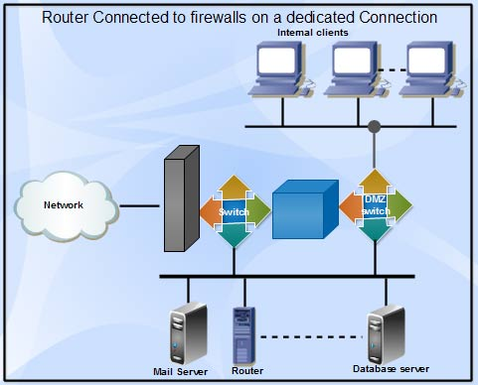
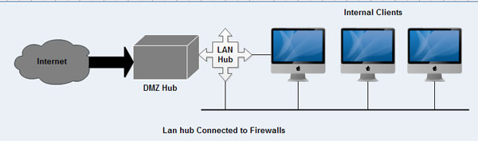
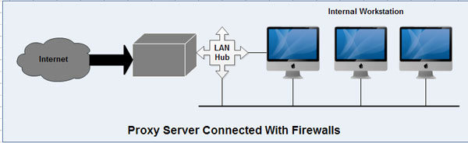
5. A proxy server on organization's LAN connected with the firewall should have rules to only allow the proxy server to connect to the Internet for the services it is providing. This way the users can get to the Internet only through the proxy.
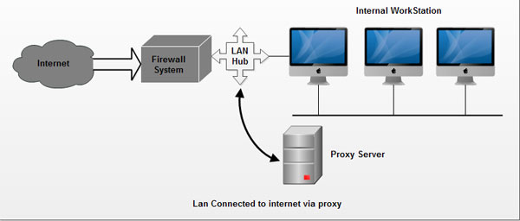

Reference
Best internet security- http://www.bestinternetsecurity.net/17/screened-subnet-architecture-the-most-common-setup-of-firewall-architecture.html
E-computer notes- Types of Firewall Architectures http://ecomputernotes.com/computernetworkingnotes/security/types-of-firewall-architectures

